**Perfect Shirley Temple**

**By**[**MAKINZE GORE**](https://www.delish.com/author/17846/makinze-gore/)

MAR 27, 2020

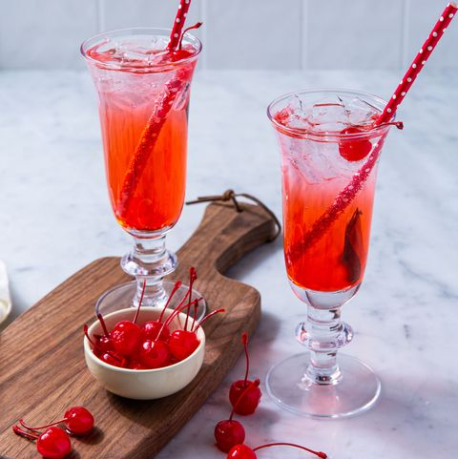

Photos by EMILY HLAVAC GREEN

It's the drink of our childhood that we all still secretly love. Sweet grenadine and fresh lime juice turns a can of soda into the perfect [non-alcoholic bubbly drink](https://www.delish.com/food/g2164/non-alcoholic-drinks/).

Ice

3 c. lemon-lime soda

Juice of 1 lime

4 tsp.

Grenadine

Maraschino cherries, for serving

1. Fill 4 glasses with ice. Divide soda and lime juice between glasses and top off with grenadine.
2. Serve with a maraschino cherry.

